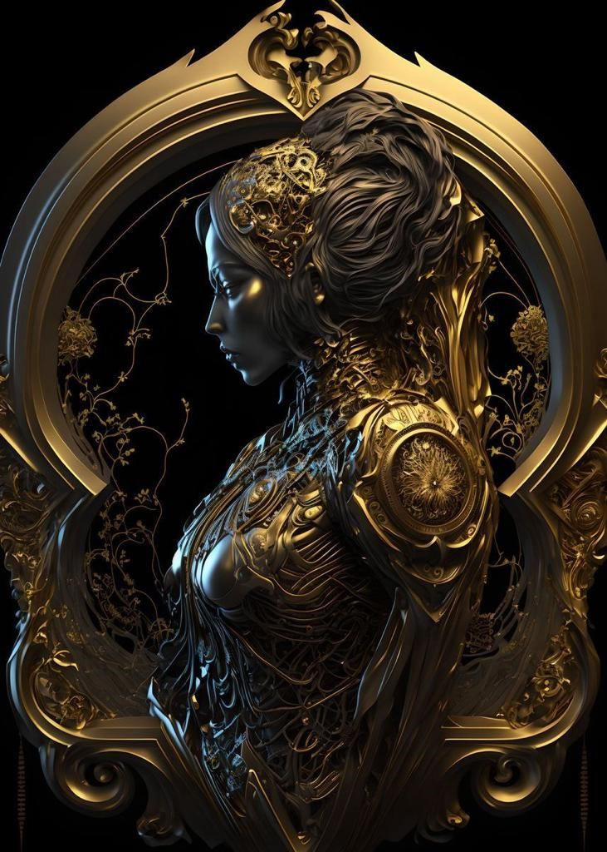

Ent Summary

There are 4 aspects of what we call the Ent Empire. The businesses (Housed under Apex Ventura), the charity (Housed under Kultivate), the media (Housed under I.P.D Ent), and the family/society (Known as the Levidians). This section specifically describes the family. ..........

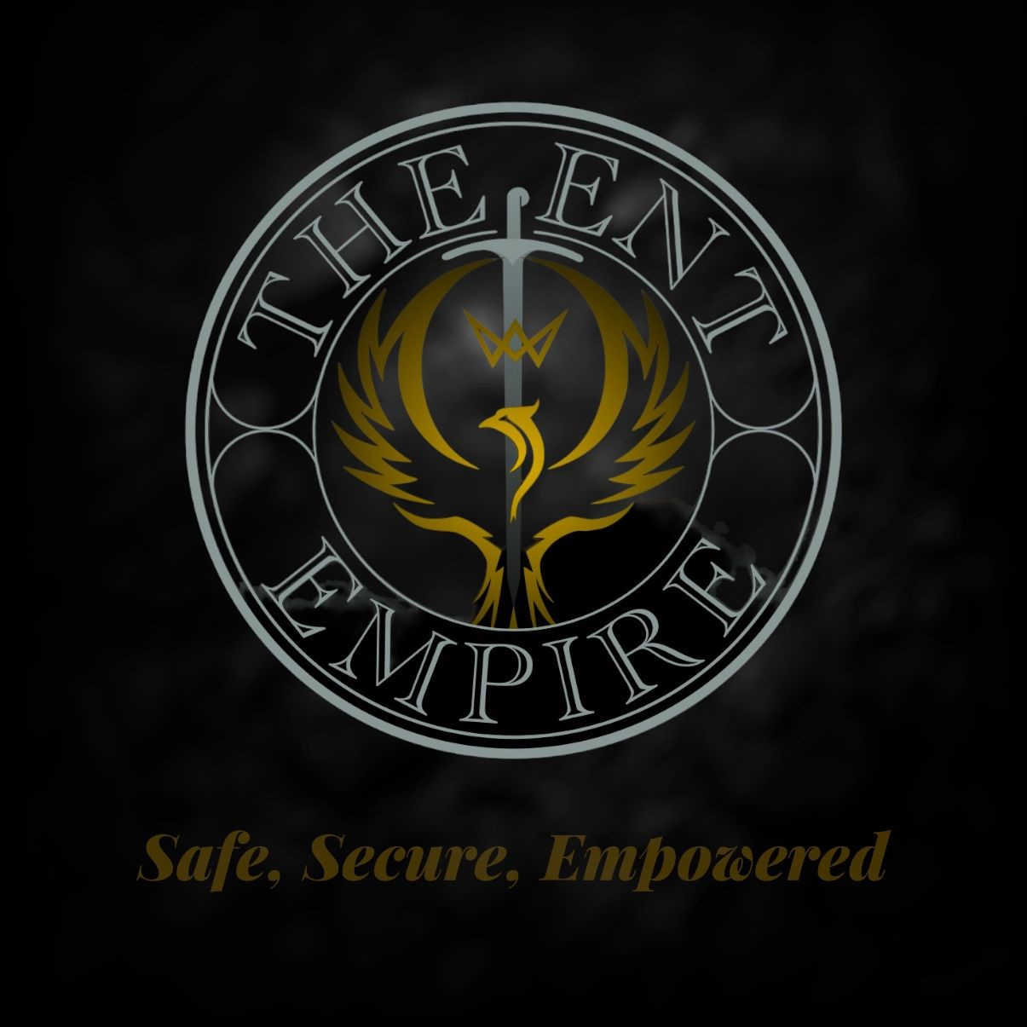
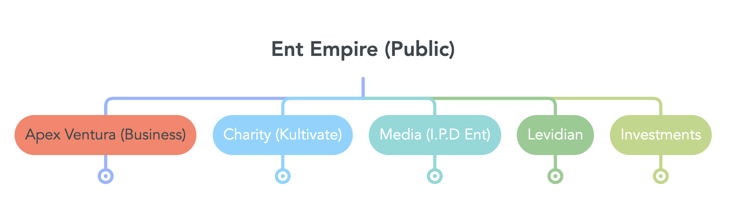In its second form it could simply be described as multiple sphere examples of these spheres are community support sphere, media sphere, business sphere, insight sphere. Withing each of these we would place everything in the Ent empire or a tool we use whose primary objective or purpose is to develop or help people in that specific medium. E.g. the community sphere would house our charity, youth centres and projects under Kultivate but would also host Levidian giveaways such as monetary support which is done through the family/society in addition to I.P.D Ent ‘voice to the voiceless’, the spheres are where you house everything that does a specific thing in one place in order to understand the full coverage of a given area of the Ent. This is mostly used internally.

In its 3rd Form, the Ent has the structure of a Dynasty or Empire. This dynasty is made up of many smaller kingdoms, each governed by a De’Draga (king) or De’Vada (queen) of the table of Ent. These kingdoms are not metaphorical/conceptual but literal areas in the Ent which specific team members are responsible for developing and maintaining. One aspect of this could be the ‘media’ for example which has various facets and subdivisions that needs to be worked on. A tertiary or beta house may be responsible for working on one of the minor facets of overall media such as marketing for example, which gives them great value but a member ranked ‘high house’ or ‘great’ may be responsible for overseeing all these facets, so they are responsible for media overall, ‘media’ being an essential tool that keeps the Ent standing is therefore classed as a pillar of Ent, being the blood line or sigil responsible for a pillar of Ent is a sign of great honour and responsibility and usually grants a bloodline/sigil more power, authority and value. These many facets keep things developing and moving forward. As time goes on De’Dragas & De’Vadas and their respective kingdoms who prove effective in their duties are allocated more resources/power which could mean moving up a rank from beta to high house for example giving you more power in decision making or for example taking lead and being qualified for a larger share of new endeavours in the form of new business ventures that they then have the luxury of maintaining/managing/ building upon, which in turn is reflected in their share, stature, power and kingdom size in the Ent. The more you do and have is the more influence and power you have. A person would lead an endeavour or run a business but would feed back to the table of its profits and loss. This operates politically as a “prove your worth” system with members and kingdom having to prove itself valuable or lucrative in order to remain involved and not face the current leader or kingdom being replaced/dissolved/ sanctioned, this incentivises each member of the table and the party they are responsible for to perform at their very best. As previously stated, some members of the table of Ent are also allocated a pillar of the Ent. The pillars of Ent are “the things which hold up the Ent empire and keeps it moving forward” these are things such as properties, finances, networks, Investments, security and other forms. Being allocated a pillar is almost a guarantee of security as it is usually seen as a permanent position which means the Ent not only considers you a permanent member but helps shoulders the responsibility of not just you but also your family, your bloodline, your nation and other things as well as gives additional financial and managerial benefits.

The Ent empire and its members follow “the clouds of Ent mandate” which details that as long as it exists in whatever form and whatever time the Ent will pursue these things, these are things such as Residual income (which is money which is had or made without the need of daily physical labour or action), Property to both live and utilise for business and investment purposes. Investments, Health and various other things.
At the top of the Ent hierarchy are the Primes who alongside the table of Ent (the Vai Esh Naa) lead and Govern the Ent. They are surrounded by the High De’Dragas (Kings) and De’Vadas (Queens) of the Ent (Gold Members). New members are generally not recruited however when they are, this is usually done via referral or recommendation from a current member based on that person standing out in some way or being referred. After these individuals are vetted, they are then tested in a very specific manner in order to evaluate their skills and characteristics from a selection of recruits. This could mean that while 15 were evaluated, only 2 are given membership. This ensures that Ent remains the best of the best and a speciality. Those two who are selected would the go through the stages of the “ceremony of the 5th” which finalises in acceptance into the Ent. (not every person is recruited in this way e.g., people in our companies or businesses are not. Only members who are looking to join the Ent empire outside of a normal working agreement and at a bronze level are.
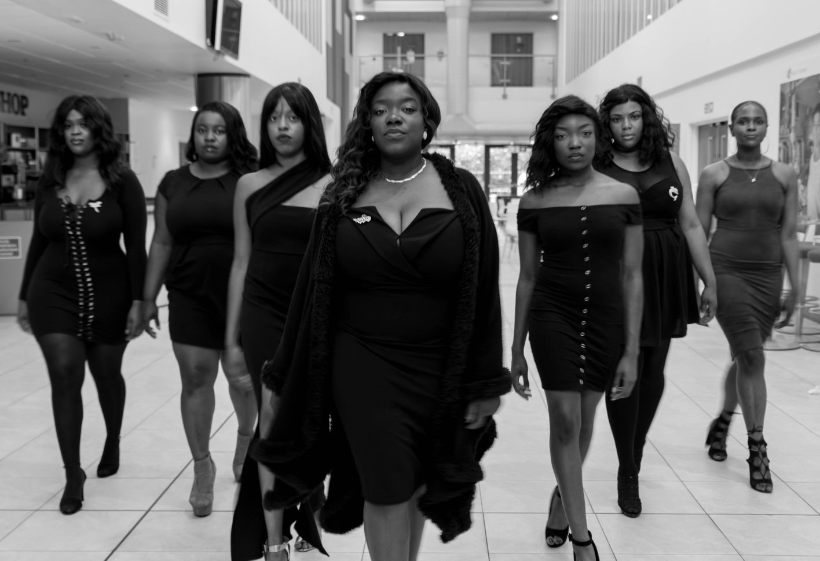
The three governing Political institutions of the Ent Empire operates as a symbiotic relationship between the Primes of Ent, the Adora Dehare, and the Cru’ix, with the Vai esh Naa (table of Ent/sigil bearers) acting as a council of sorts when it comes to day to day running. A member of the Ent Empire cannot ascend to the position of prime without the approval and support of the two other institutions, with both sides of the fence being responsible for various duties and responsibilities that keeps the Ent empire safe and moving. This is things such as the bylaws of Ent which are our governing laws and the enforcement of such as well as security codes and financial approvals of endeavours. This creates a sense of accountability and responsibility and representation within the Ent and ensures only the very best and most capable are at the forefront while maintaining the core belief of survival of the fittest. By design One institution cannot operate without the support of the others, to create a sense of accountability and harmony therefore balance and compromises are always found, and all parties operate with transparency to inform and alleviate the others. The Ki’Et is a group of individuals who are not recognised as political bodies of the Ent empire or as formal members in the chain of ascension but play a vital (unspecified) role within the Ent empire. The identity of the members of this institution are not known by anyone outside of a prime.

There is our business, called Apex Ventura which has various subsidiaries underneath it that does various things Such as Tribal, Infinity alliance, Lions Corp, momentum investment groups, Synergy, and E.I.C. The purpose of this business and the vast majority of Every person across the entire is to build this to a point where we are making a minimum of -- million Net per year.
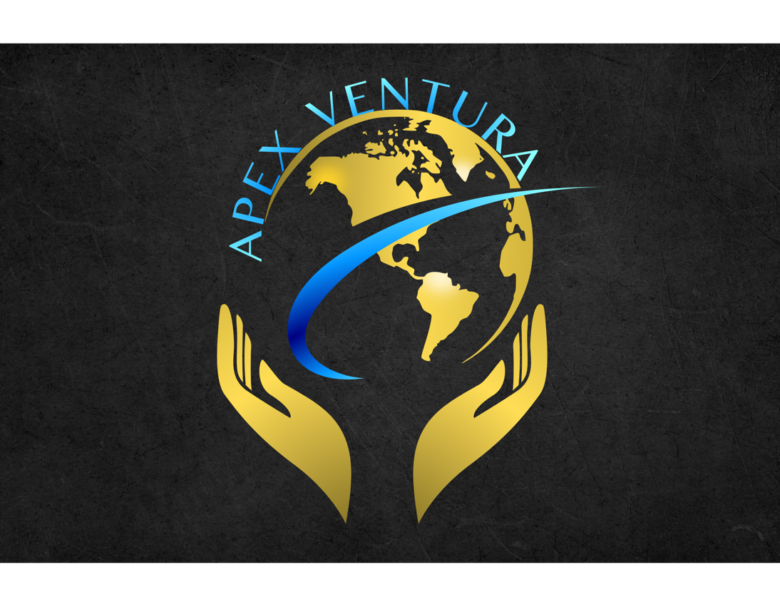
How we intend to do this is through Insurance, Loans, finance, and healthcare services. In addition, we have huge focuses on things that generate a lot of unit sales in the form of products, as well as technology that generates micro transactions such as our Apps, and various venues that generates profits such as our restaurants, Nightclubs, E kitchen and take aways. (see plans for details)
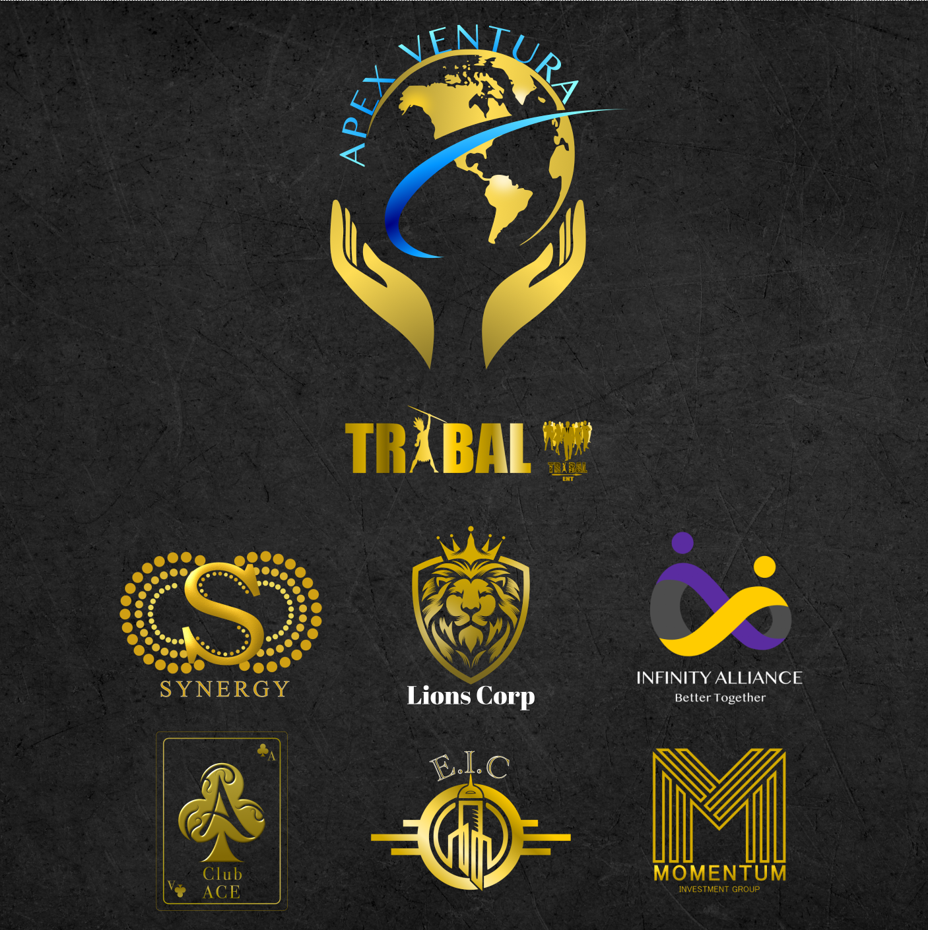

The second part of the Ent empire is the charitable endeavours housed under Kultivate.

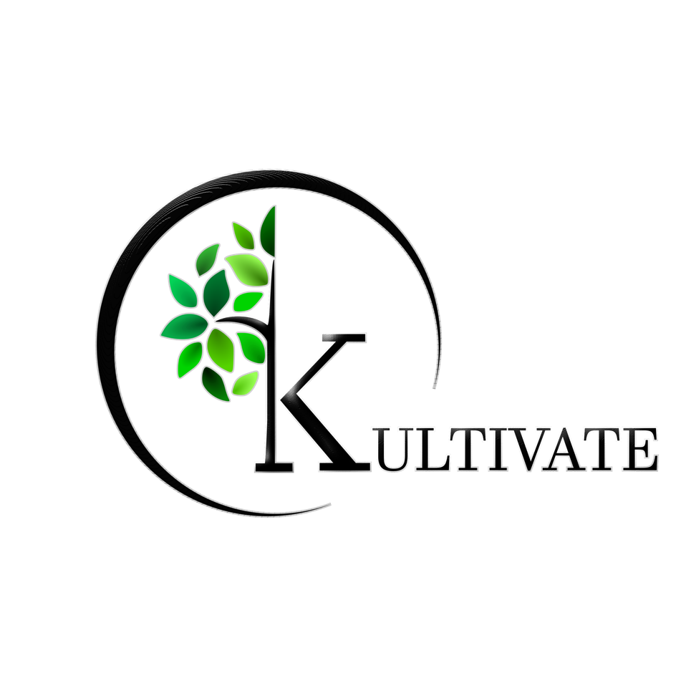
Kultivate runs projects that are funded by others that enables us to help people, this is projects such as challenging gangs, homelessness, disability youth development etc. on a good year until we get bigger and better, we look forward to making half a million per quarter.
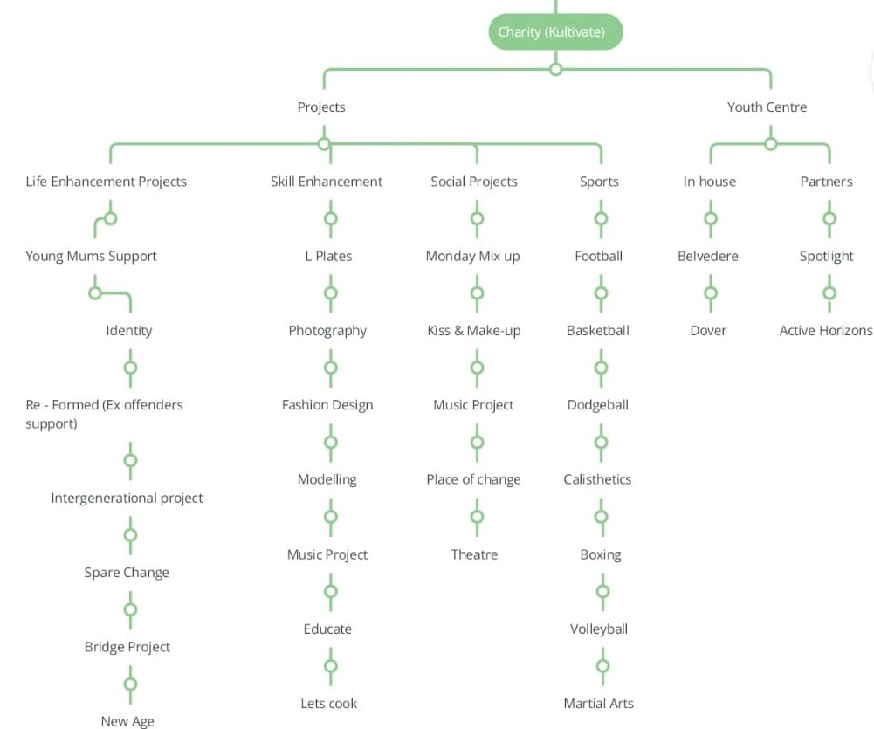


The third aspect of us is media, Known as I.P.D Ent we have various media and brand which includes launching our own production company, recruiting, and releasing our own artists, launching our own magazines etc.
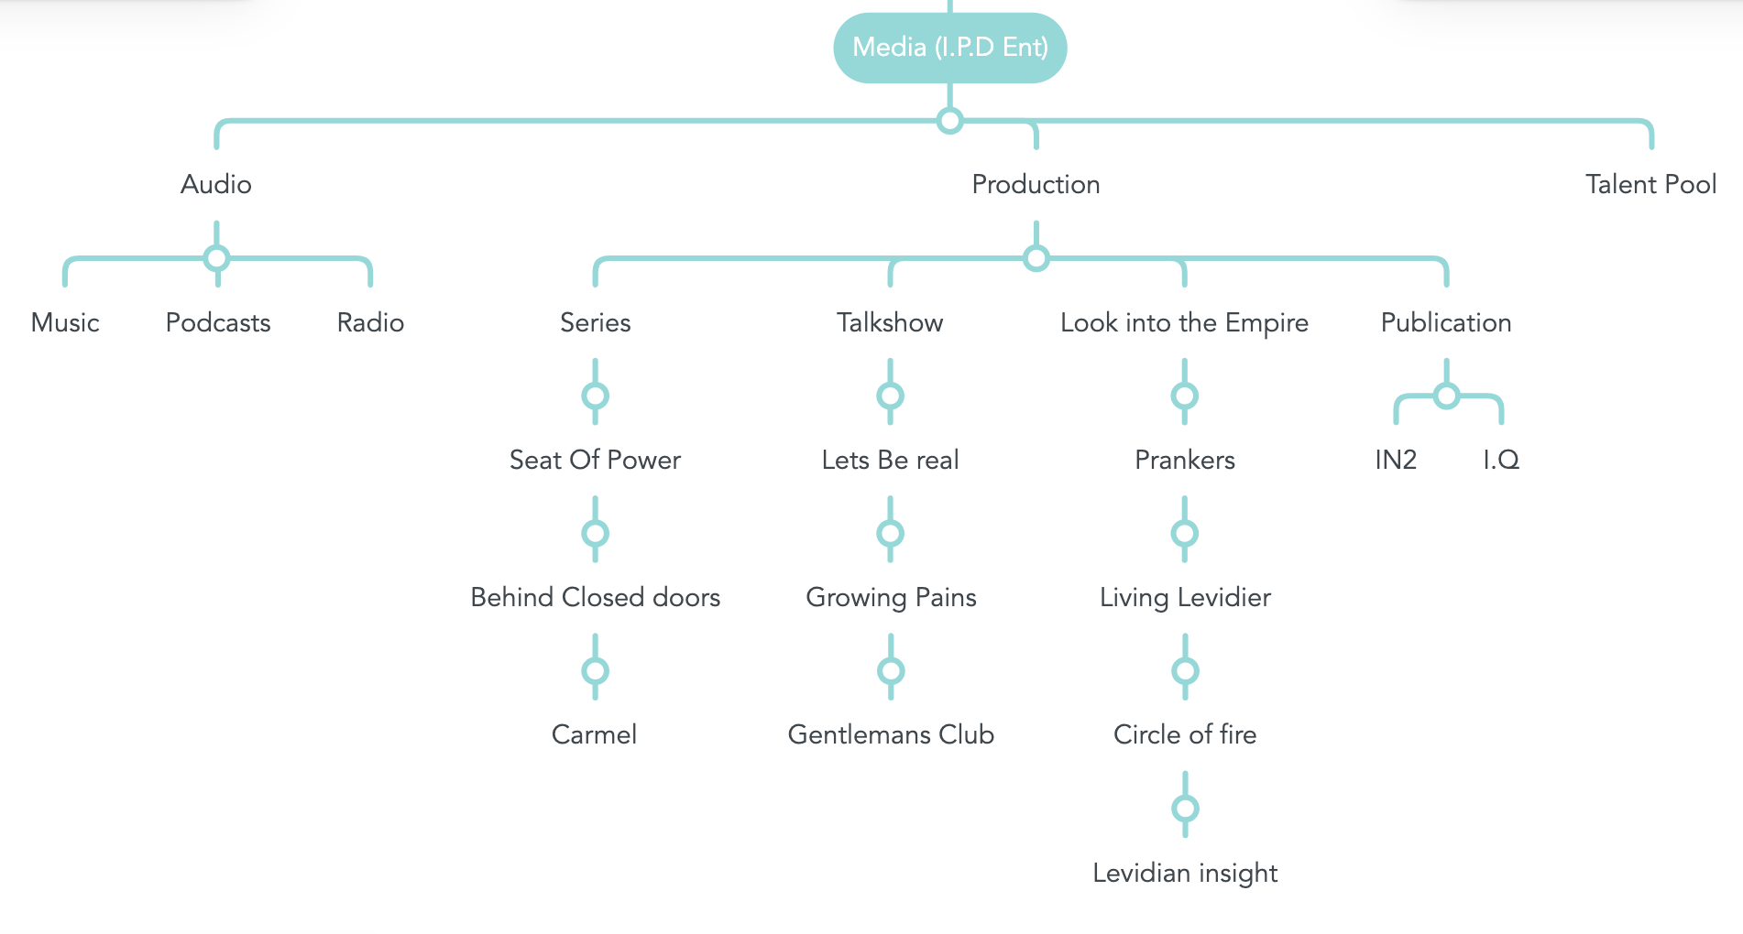

The last aspect of the Ent empire is the Levidian society formally known as the Levidian family, but we have expanded a bit too far to just be a family now.
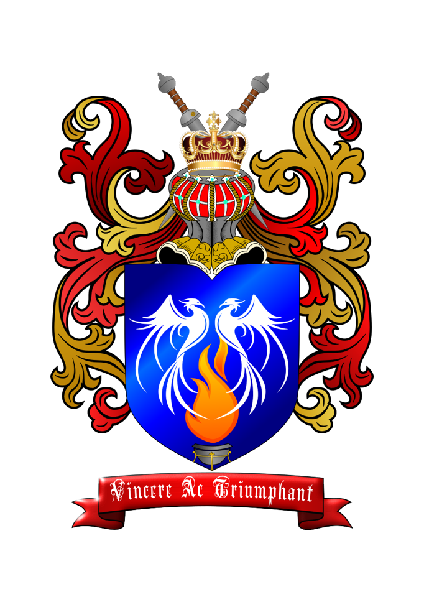
There are two aspects of this the first aspect of it is the group of people who run all the Ent empire or enables it to exist. This is broken down into the 36 seats of control, represented by the blood lines of the animal sigils given to various key members that plays substantial roles in Ent society or enabling it to stand strong, secure, and profitable. They are Followed by an estimated 320 – 420 other people who follows them and makes up our society known as initiates. They do jobs and plays roles that enables us to exist thrive and grow. And we in term use our influence, networks, connections, resources, and capability to enable them to rise and make their lives easier. These 36 Levidians are known as the “Levidian Family” or “the table of Ent” members. Profits from all aspects of the Ent empire is calculated and divided up and each person with a sigil gets a share of it, the more powerful your sigil is based on a member or their families your effectiveness, and capability is the larger the share they get. These 36 sigils are broken down into (currently 4) generations, usually 9 active sigils make up a generation, the first 9 sigils are called the ‘originals’ and are the foundations of the Ent Empire. There are 3 more generations that came after the originals known as the ‘Nets’, ‘Infinities’, and the ‘Unnamed’. These 36 sigils that span 4 generations of Levidians are divided into smaller factions tasked with their own unique missions. Some of these teams are known as the Levidian Al She’ahd, the Levidian Cru’ix, the Sages, Clandestines, the Guild, the Sah’Gem and other. Together they make up the general leading body of the Ent known as ‘The table of Ent, the sigil bearers’ or in Levidian language ‘Vai Esh Naa’
While The Ent typically does operate as a democracy with members of the table often making decisions as one big group it does have clear leaders known as primes and a strong political structure between the triad of the three (Primes, Al She’Ahd, and Cru,ix)
Sol’En and Ani’hala are Primes of the Ent, and they are who each sigil pledges to and who pledges to each sigil in return to create cohesion and prevent infighting from affecting the Ent because of personal feelings or animosity that may brew between the members occasionally impeding progress. It’s natural that some people may not always get along or be in control of their emotion. It means everybody stands a chance of gaining fairly, according to their work as long as their membership is acknowledged by the primes.
Not all Sigil members are public members however as specific people from the Ent are chosen to publicly go fourth and represent the brand in the way the brand has approved. In the role of brand ambassadors some members attend various events on behalf of the Ent do public speaking as well as broker deals, negotiate acquire and represent on behalf of the Ent Empire and Levidian brand.
Every member of the table of Ent signs nondisclosures, non competes, image consents and a variety of other contracts to be eligible.
36 Members, making up or leading teams of others, tasked with different missions, goals or endeavours that once successful allows us to reach our 20 year goal of having a net profit turnover of …. million per year. Meaning in the areas that matter to each of us we leave a legacy of achievement wealth and prosperity. With various additional people who enable our strength.
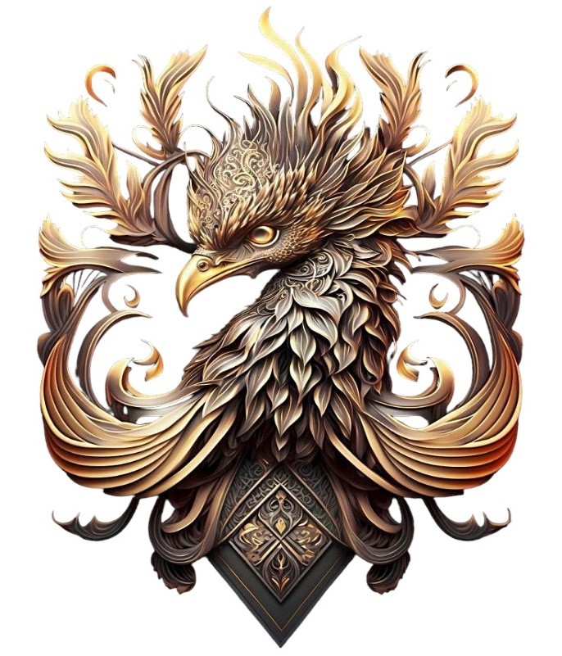

The First Generation
Known as the original lords and ladies of Levidier. The first of the Family. They built and continue to build the foundations on which all else stands.

The Lions: Seat of Sol’En (Prime all sect), The Swans: Seat of Ani’Hala (Prime Al She’Ahd), The Forest Wolf: seat of Des’iah, The Dolphin: Seat of O’Cen, The Ox: Seat of Ze’Hari, The Bear: Seat of Di’Ursa, The Mountain Wolf: Seat of Veh’Lore, The Tiger: Seat of Tal’Vien, The Silverback: Seat of Sil’Viere.

DEHARA Levidier!

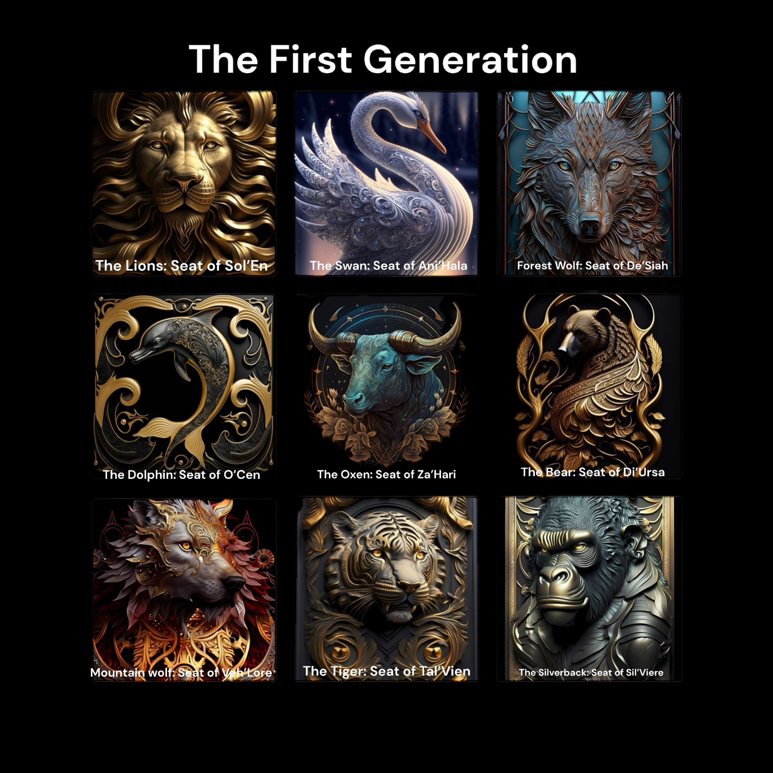

The Second Generation
They were essential to the stability Growth and strength of our family During the Net uncertainty. And you continue to be by handling matters and missions in our alternative areas of business, and Investments.

The Falcon: Seat of Mih’en, The Deer: Seat of Lah’os, The Hawk: Seat of Kea’Meh, The Shark: Seat of Vi’Sien, The Jaguar: Seat of Ava’Len, The Stallion: Seat of Ste’Lia, The Fox: Seat of Ra’Wan, The Rhino: Seat of Ala’Han, The Komodo: Seat of O.Mah

DEHARA Levidier!

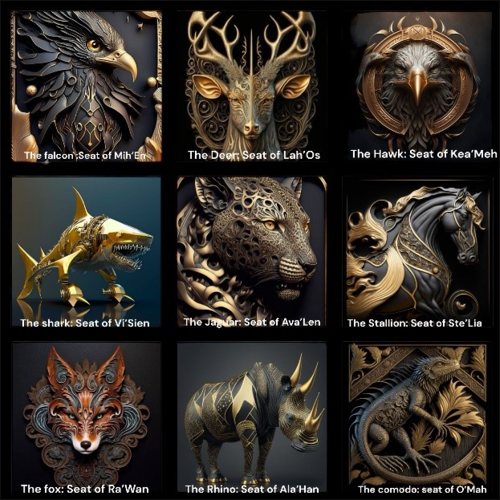

The Third Generation
The men and women that built Infinity! These men and women possess a level of power, qualities, strengths, skills, and capability that has not been often seen since the first generation.

The Owl: Seat of Na’Tier, The Viper: Seat of Tehl’En, The Ram: Seat of Bel’Azu, The Butterfly: Seat of Al’Zeya, The Beetle: Seat of An’Ori, The Hare: Seat of O’Sah, The Dog: Seat of Tah’Ai, The Scorpion: Seat of Di’Ej, The Elephant: Seat of Ka’Hi

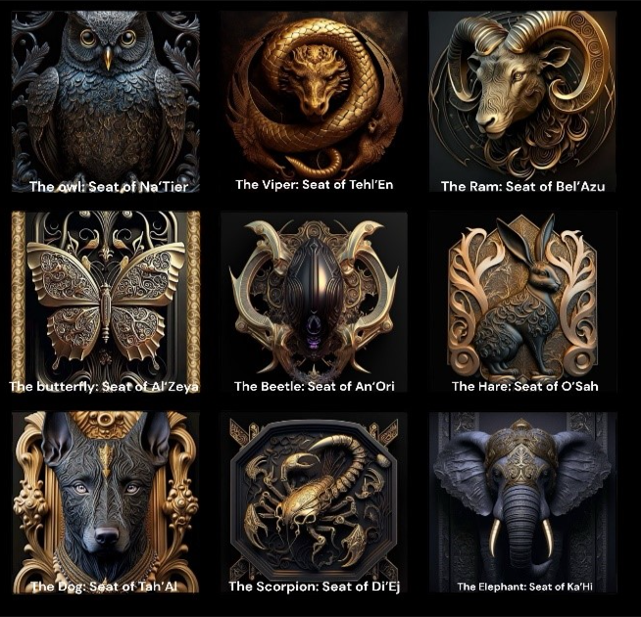

The Fourth Generation
What they do cannot be named but they are essential to our standing!
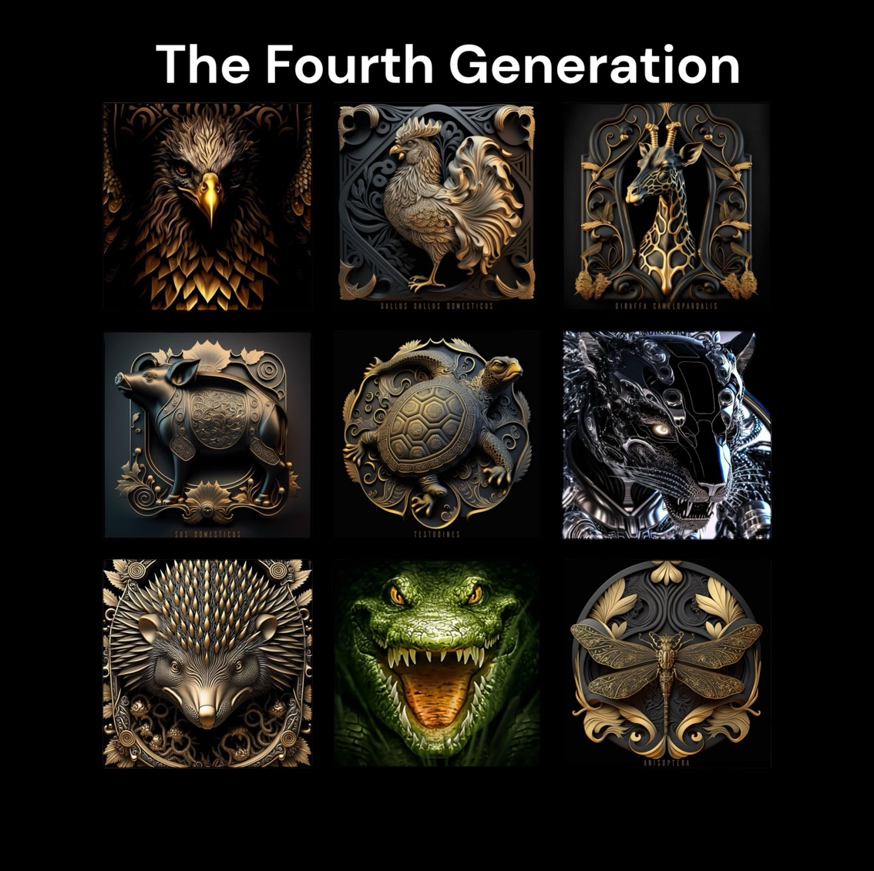

The Factions

