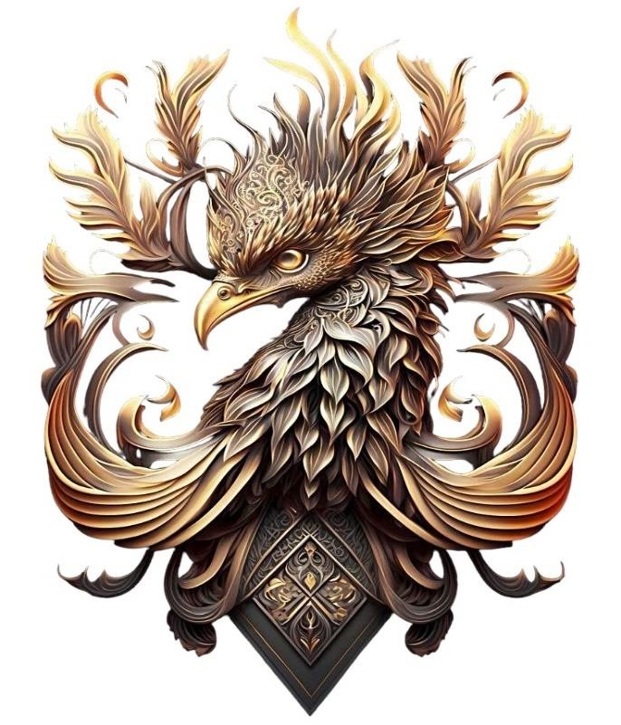

The last aspect of the Ent empire is the Levidian society formally known as the Levidian family, but we have expanded a bit too far to just be a family now.

There are two aspects of this the first aspect of it is the group of people who run all the Ent empire or enables it to exist. This is broken down into the 36 seats of control, represented by the blood lines of the animal sigils given to various key members that plays substantial roles in Ent society or enabling it to stand strong, secure, and profitable. They are Followed by an estimated 320 – 420 other people who follows them and makes up our society known as initiates. They do jobs and plays roles that enables us to exist thrive and grow. And we in term use our influence, networks, connections, resources, and capability to enable them to rise and make their lives easier. These 36 Levidians are known as the “Levidian Family” or “the table of Ent” members. Profits from all aspects of the Ent empire is calculated and divided up and each person with a sigil gets a share of it, the more powerful your sigil is based on a member or their families your effectiveness, and capability is the larger the share they get. These 36 sigils are broken down into (currently 4) generations, usually 9 active sigils make up a generation, the first 9 sigils are called the ‘originals’ and are the foundations of the Ent Empire. There are 3 more generations that came after the originals known as the ‘Nets’, ‘Infinities’, and the ‘Unnamed’. These 36 sigils that span 4 generations of Levidians are divided into smaller factions tasked with their own unique missions. Some of these teams are known as the Levidian Al She’Ahd, the Levidian Cru’ix, the Sages, Clandestines, the Guild, the Sah’Gem and others. Together they make up the general leading body of the Ent known as ‘The table of Ent, the sigil bearers’ or in Levidian language ‘Vai Esh Naa’

While The Ent typically does operate as a democracy with members of the table often making decisions as one big group it does have clear leaders known as primes and a strong political structure between the triad of the three (Primes, Al She’Ahd, and Cru’ix)

Sol’En and Ani’hala are Primes of the Ent, and they are who each sigil pledges to and who pledges to each sigil in return to create cohesion and prevent infighting from affecting the Ent because of personal feelings or animosity that may brew between the members occasionally impeding progress. It’s natural that some people may not always get along or be in control of their emotion. It means everybody stands a chance of gaining fairly, according to their work if their membership is acknowledged by the primes.

Not all Sigil members are public members however as specific people from the Ent are chosen to publicly go fourth and represent the brand in the way the brand has approved. In the role of brand ambassadors some members attend various events on behalf of the Ent do public speaking as well as broker deals, negotiate acquire and represent on behalf of the Ent Empire and Levidian brand.

Every member of the table of Ent signs nondisclosures, non competes, image consents and a variety of other contracts to be eligible.

36 Members, making up or leading teams of others, tasked with different missions, goals or endeavours that once successful allows us to reach our 20-year goal of having a net profit turnover of …. per year. Meaning in the areas that matter to each of us we leave a legacy of achievement wealth and prosperity. With various additional people who enable our strength.

# The First Generation

Known as the original lords and ladies of Levidier. The first of the Family. They built and continue to build the foundations on which all else stands.

The Lions: Seat of Sol’En (Prime all sect), The Swans: Seat of Ani’Hala (Prime Al She’Ahd), The Forest Wolf: seat of Des’iah, The Dolphin: Seat of O’Cen, The Ox: Seat of

Ze’Hari, The Bear: Seat of Di’Ursa, The Mountain Wolf: Seat of Veh’Lore, The Tiger: Seat of Tal’Vien, The Silverback: Seat of Sil’Viere.

DEHARA Levidier!

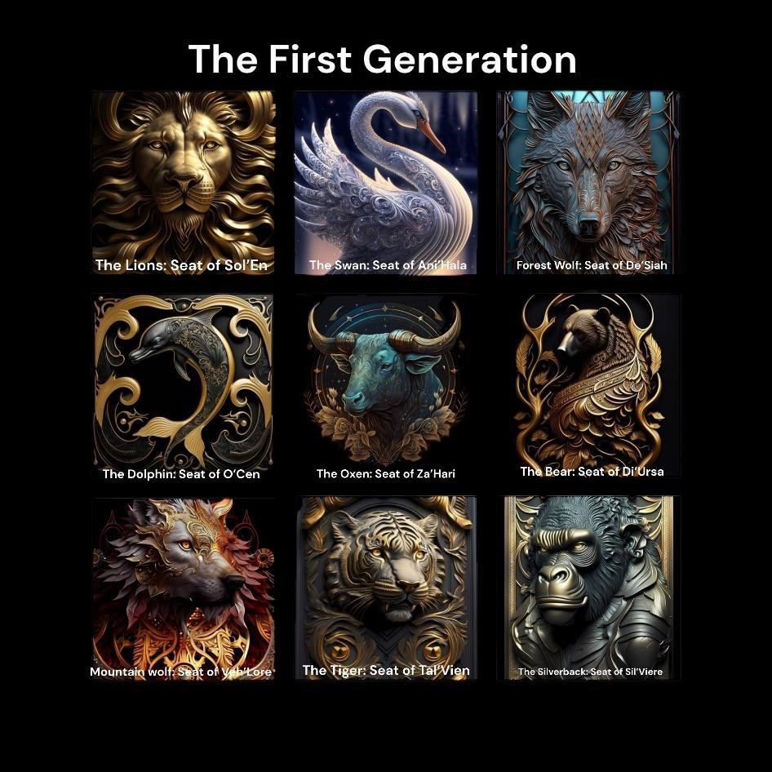

# The Second Generation

They were essential to the stability Growth and strength of our family During the Net uncertainty. And you continue to be by handling matters and missions in our alternative areas of business, and Investments. DEHARA Levidier!

The Falcon: Seat of Mih’en, The Deer: Seat of Lah’os, The Hawk: Seat of Kea’Meh, The Shark:

Seat of Vi’Sien, The Jaguar: Seat of Ava’Len, The Stallion: Seat of Ste’Lia, The Fox: Seat of

Ra’Wan, The Rhino: Seat of Ala’Han, The Komodo: Seat of O’Mah

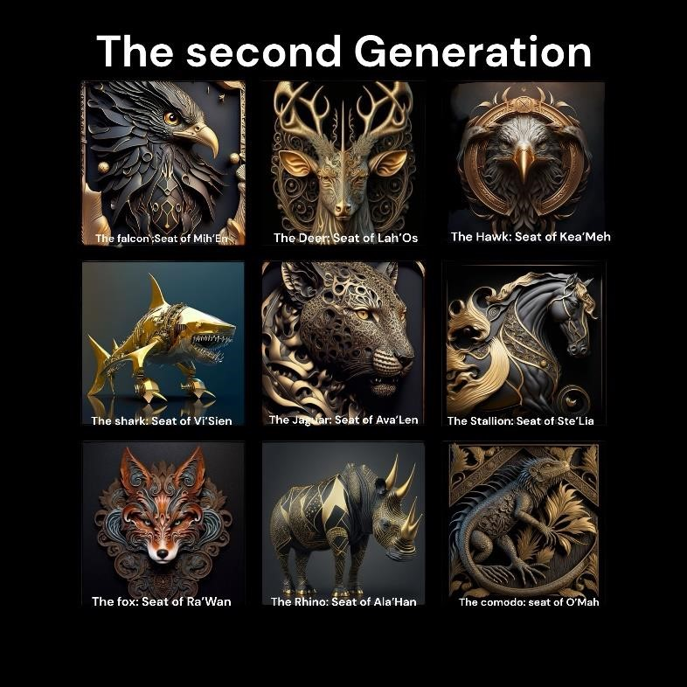

# The Third Generation

The men and women that built Infinity! These men and women possess a level of power, qualities, strengths, skills, and capability that has not been often seen since the first generation.

The Owl: Seat of Na’Tier, The Viper: Seat of Tehl’En, The Ram: Seat of Bel’Azu, The Butterfly: Seat of Al’Zeya, The Beetle: Seat of An’Ori, The Hare: Seat of O’Sah, The Dog: Seat of Tah’Ai, The Scorpion: Seat of Di’Ej, The Elephant: Seat of Ka’Hi

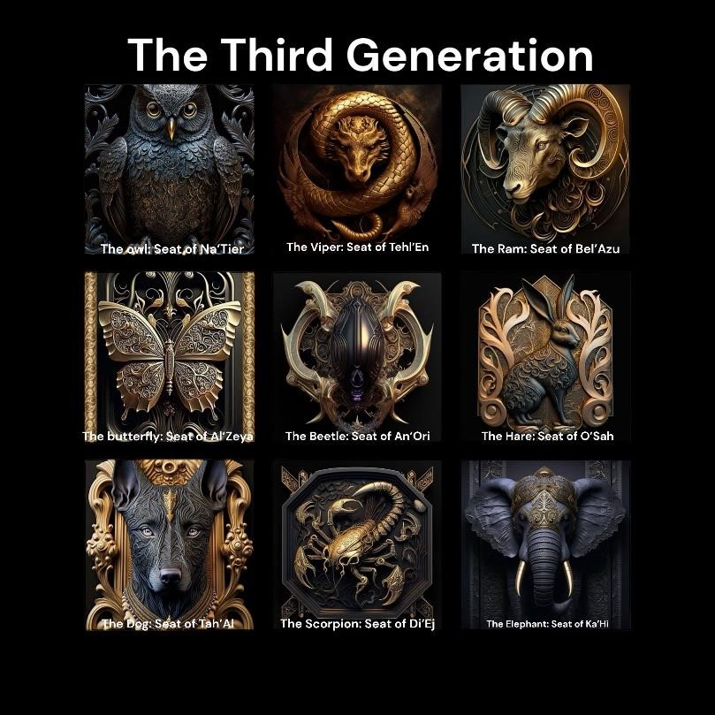

# The Fourth Generation

What they do cannot be named but they are essential to our standing!

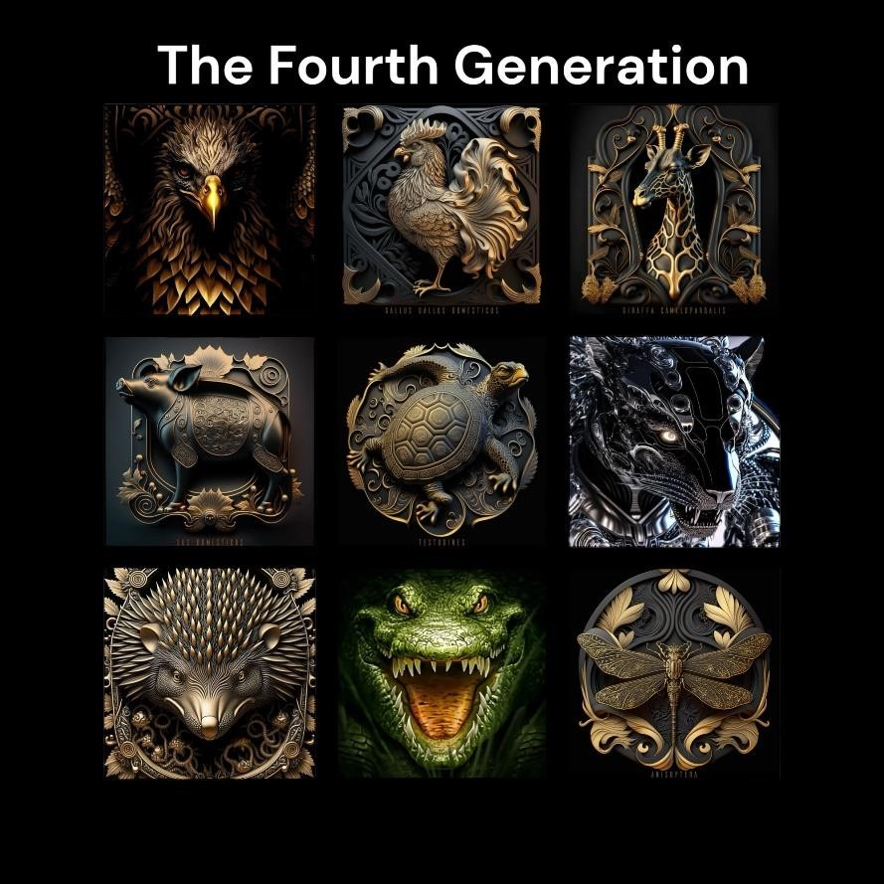

# The Factions

